CONSUMER FINANCIAL COMPLAINTS
Consumer Financial Protection Bureau (CFPB)
EXECUTIVE OVERVIEW
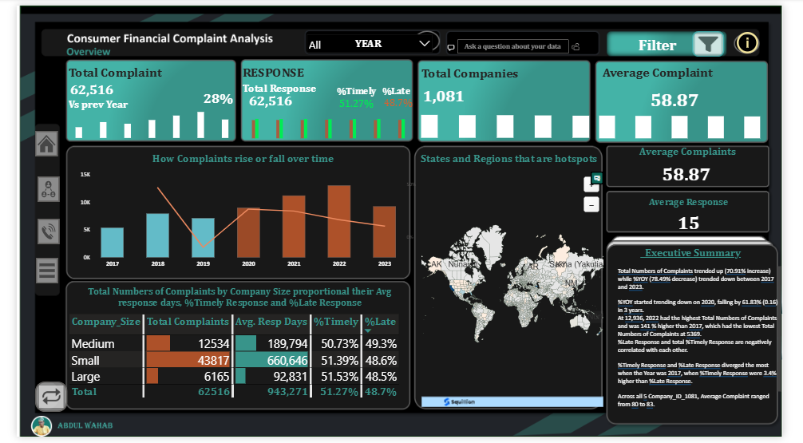
COMPLAINTS ANALYSIS
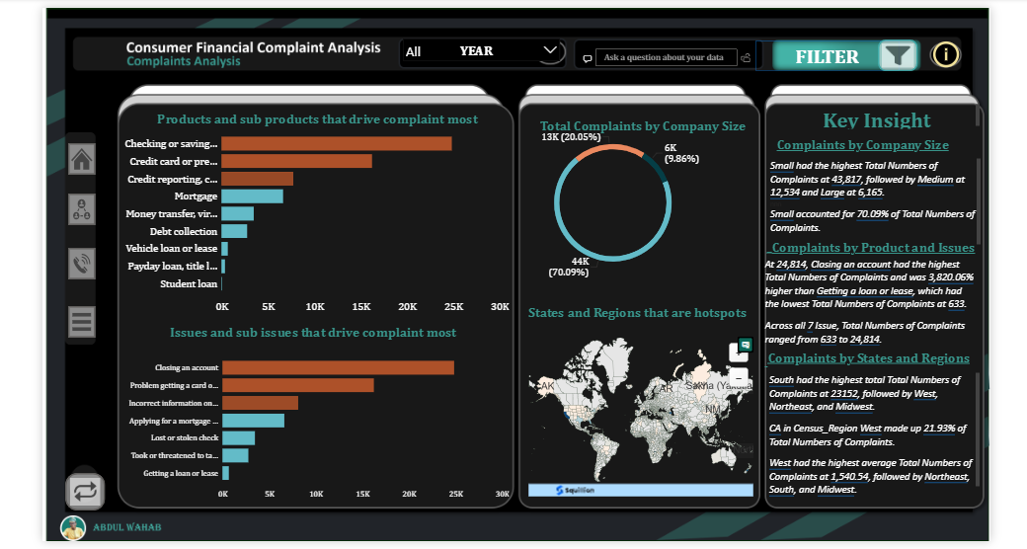
RESPONSE ANALYSIS
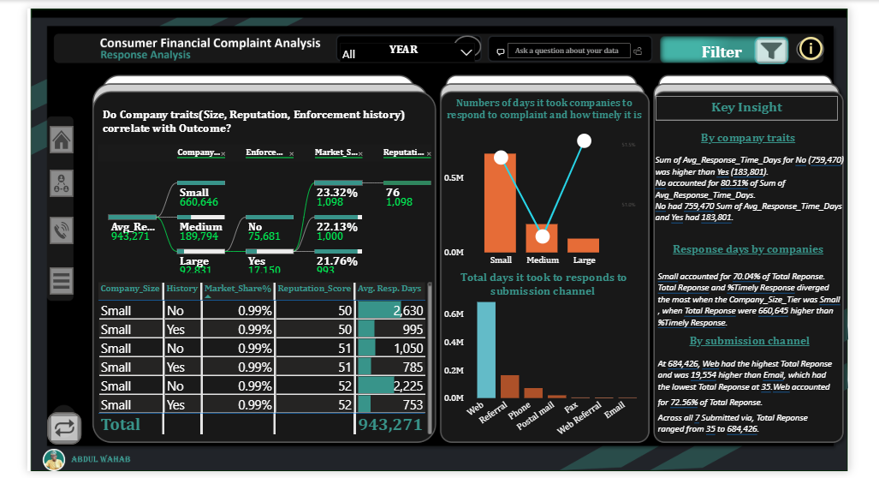

DETAILS AND RECOMMENDATION
